**Practical 1**

**Aim: To install Hadoop framework, configure it and setup a single node cluster. Use web-based tools to monitor your Hadoop setup.**

**Hadoop Installation:**

Step 1 – Download and Install Java

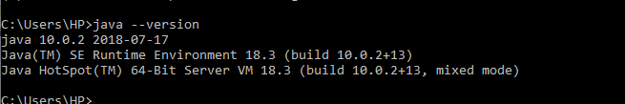

Step 2 – Download Hadoop and Extract it to a Folder

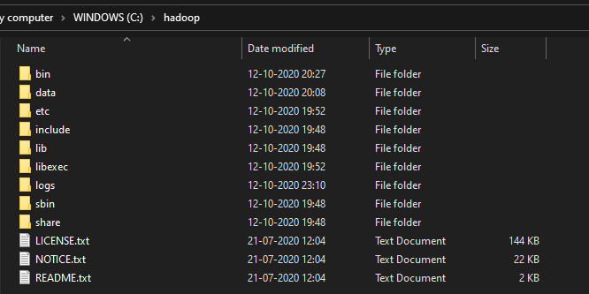

Step 3 – Setup System Environment Variables

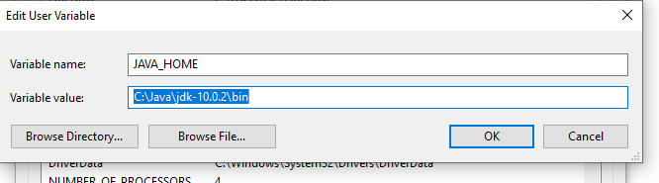

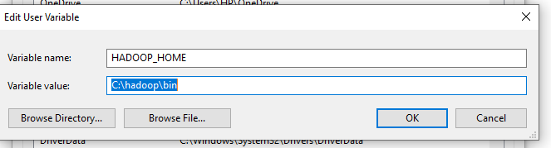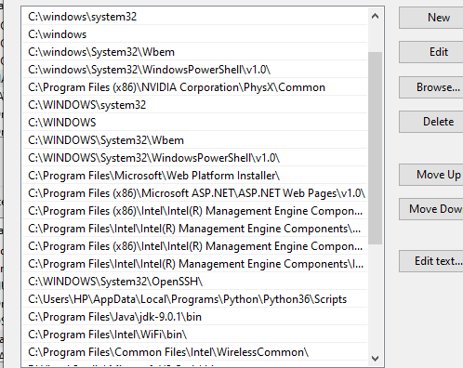

Step 4 - Now we need to edit some files located in the Hadoop directory of the etc folder

List of files need to be edited:

core – site.xml

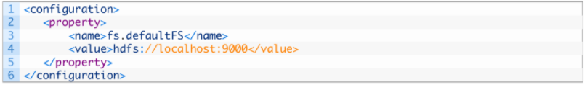

mapred – site

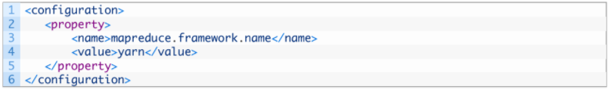

Create a folder ‘data’ and other two subfolders ‘datanode’ and ‘namenode’ in hadoop directory.

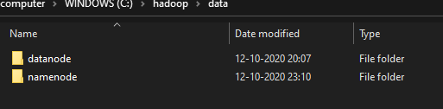

Edit the file hdfs-site.xml and add below property in the configuration Note: The path of namenode and datanode across value would be the path of the datanode and namenode folders you just created.

Hdfs – site

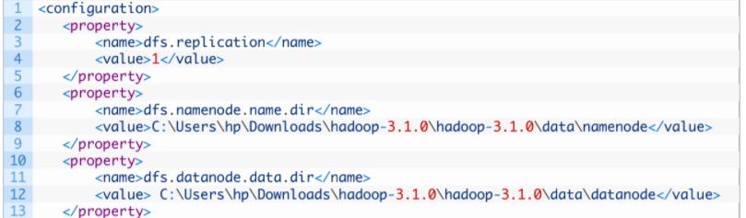

yarn – site

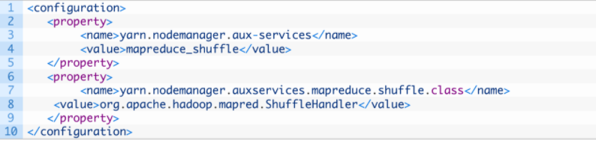

Edit hadoop-env.cmd and replace %JAVA_HOME% with the path of the java jdkfolder

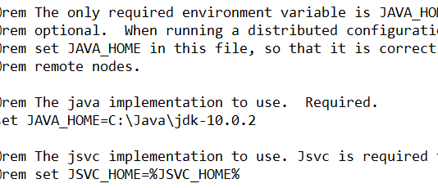

Step 5 – Hadoop needs windows OS specific files which does not come with default download of Hadoop

To include those files, replace the bin folder in Hadoop directory with the bin folder provided in this github link.

<https://github.com/s911415/apache-hadoop-3.1.0-winutils>

Download it as zip file. Extract it and copy the bin folder in it. If you want to save the old bin folder, rename it like bin_old and paste the copied bin folder in that directory.

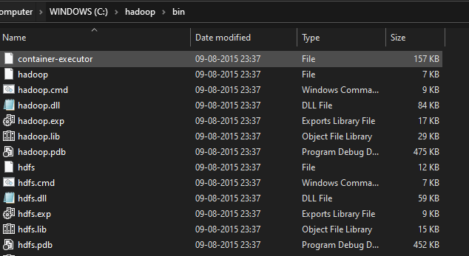

Step 6 – Check whether Hadoop is successfully installed by running this command on cmd-

hadoop version

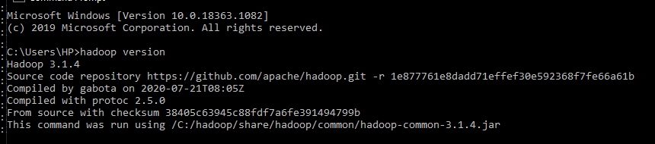

Since it doesn’t throw error and successfully shows the Hadoop version, that means Hadoop is successfully installed in the system.

Formatting the NameNode is done once when Hadoop is installed and not for running Hadoop file system, else it will delete all the data inside HDFS. Run this command-

hdfsnamenode -format

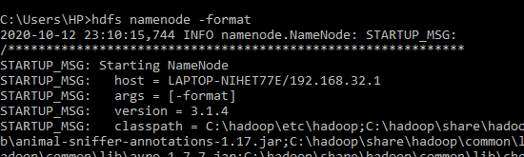

Step 7 - Now change the directory in cmd to sbin folder of Hadoop directory with this command, (Note: Make sure you are writing the path as per your system)

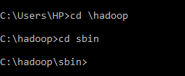

Step 8 – Start namenode and datanode with this command –

start -dfs.cmd

Two more cmd windows will open for NameNode and DataNode Now start yarn through this command-

start -yarn.cmd

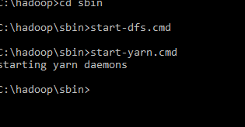

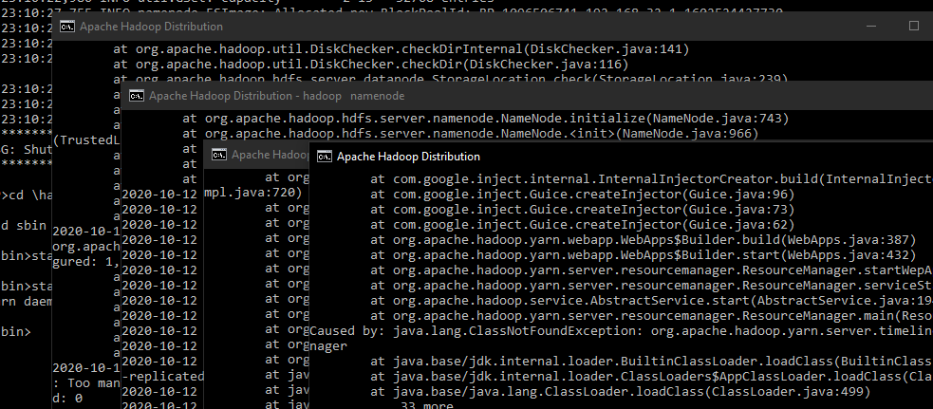

Note: Make sure all the 4 Apache Hadoop Distribution windows are up running. If they are not running, you will see an error or a shutdown message. In that case, you need to debug the error

Step 9 - To access information about resource manager current jobs, successful and failed jobs, go to this link in browser-

<http://localhost:8088/cluster>

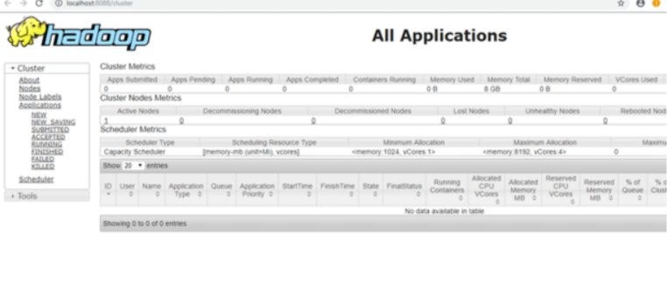

Step 10 - To check the details about the hdfs (namenode and datanode),

Open this link on browser-

<http://localhost:9870/>

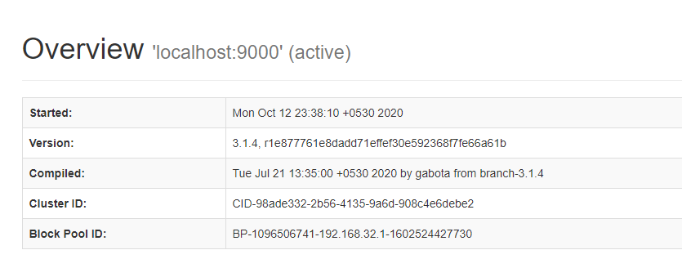

**Working with HDFS**

1. We will be using a text file in local file system
2. We will create a directory name ‘sample’ in my hadoop directory using the cmd –

hdfsdfs -mkdir /sample

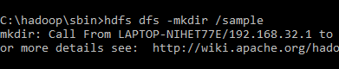

1. To verify if the directory is created in hdfs, use ‘ls’ cmd which will list the files present in hdfs

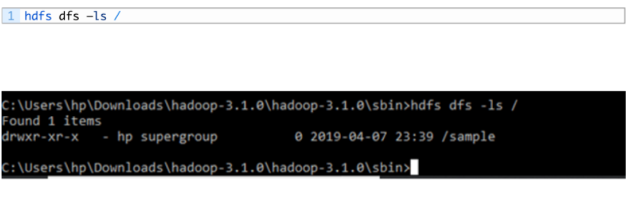

1. Copy the text file named ‘potatoes’ from local file system to the folder we just created in hdfs using copyFromLocalcmd –

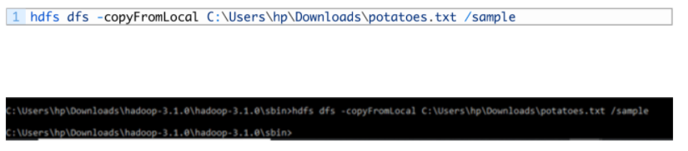

1. To verify if the file is copied to the folder, I will use ‘ls’ command by specifying the folder name which will read the list of files in that folder –



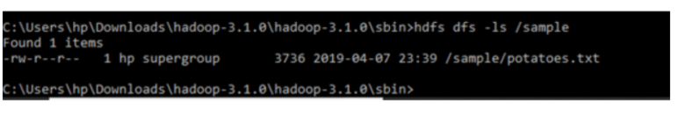

1. To view the contents of the file we copied, I will use cat command-

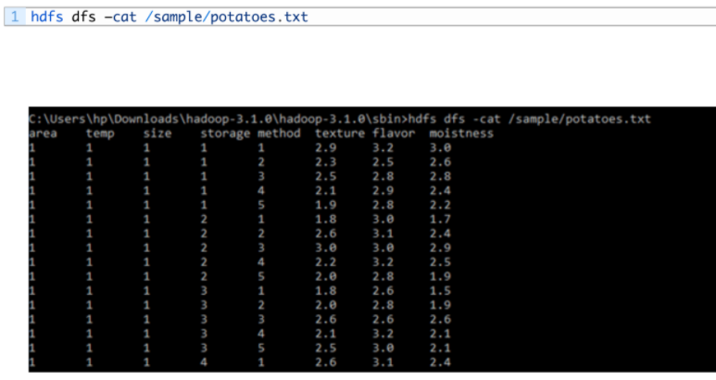

1. To Copy file from hdfs to local directory, I will use get command-

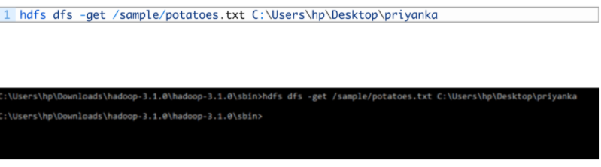

**These were some basic Hadoop commands.**

**Practical 2**

**Aim: To implement file management tasks in Hadoop HDFS and perform Hadoop commands.**

With growing data velocity, the data size easily outgrows the storage limit of a machine. A solution would be to store the data across a network of machines. Such filesystems are called *distributed filesystems*. Since data is stored across a network all the complications of a network come in.  
This is where Hadoop comes in. It provides one of the most reliable filesystems. HDFS (Hadoop Distributed File System) is a unique design that provides storage for *extremely large files*with streaming data access pattern and it runs on *commodity hardware*. Let’s elaborate the terms:

* ***Extremely large files***: Here we are talking about the data in range of petabytes (1000 TB).
* ***Streaming Data Access Pattern***: HDFS is designed on principle of *write-once and read-many-times*. Once data is written large portions of dataset can be processed any number times.
* ***Commodity hardware:***Hardware that is inexpensive and easily available in the market. This is one of feature which specially distinguishes HDFS from other file system.

**Syntax and Commands to Add, Retrieve and Delete Data From HDFS:**

Adding Files and Directories to HDFS: Before you'll run Hadoop programs on data stored in HDFS, you ‘ll got to put the info into HDFS first. Let ‘s creates a directory and put a enter it. HDFS features a default working directory of /user/$USER, where $USER is your login user name. This directory isn‘t automatically created for you, though, so let ‘s creates it with the mkdir command. For the aim of illustration, we use chuck. you ought to substitute your user name within the example commands. Hadoop fs -mkdir /user/chuck

hadoop fs -put example.txt

hadoop fs -put example.txt /user/chuck

Retrieving Files from HDFS: The Hadoop command get copies files from HDFS back to the native filesystem. To retrieve example.txt, we are ready to run the next command:

hadoop fs -cat example.txt

Deleting Files from HDFS hadoop fs -rm example.txt. Command for creating a directory in hdfs is

“hdfsdfs –mkdir /lendicse”.

Adding directory is done through the command “hdfsdfs –put lendi_english /”.

Copying Data from NFS to HDFS:

* + Copying from directory command is “hdfsdfs –copyFromLocal /home/lendi/Desktop/shakes/glossary /lendicse/”
  + View the file by using the command “hdfsdfs –cat /lendi_english/glossary”
  + Command for listing of things in Hadoop is “hdfsdfs –ls hdfs://localhost:9000/”. Command for Deleting files is “hdfsdfs –rm r /example”.

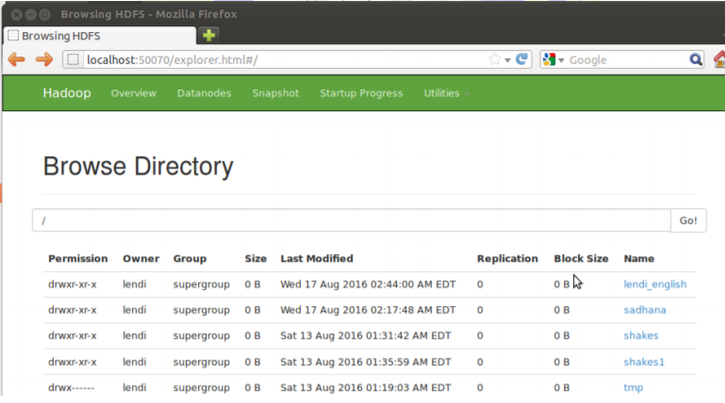

**Hadoop Commands:**

1. **ls:** This command is employed to list all the files. Use lsr for recursive approach. it's useful once we need a hierarchy of a folder.

Syntax: bin/hdfsdfs -ls

Example: bin/hdfsdfs -ls /

It will print all the directories present in HDFS. bin directory contains executables so, bin/hdfs means we would like the executables of hdfs particularly dfs (Distributed File System) commands.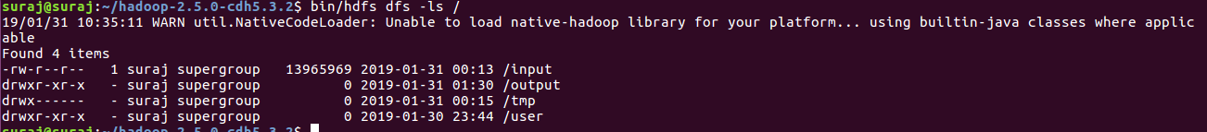

1. **mkdir**: To create a directory. In Hadoop dfs there's no home directory by default. So, let’s first create it.

Syntax:

bin/hdfsdfs -mkdir

creating home directory:

hdfs/bin -mkdir /user

hdfs/bin -mkdir /user/username

Example:

bin/hdfsdfs -mkdir /geeks => '/' means absolute path

bin/hdfsdfs -mkdir geeks2 => Relative path -> the folder are going to be created relative tothe house directory.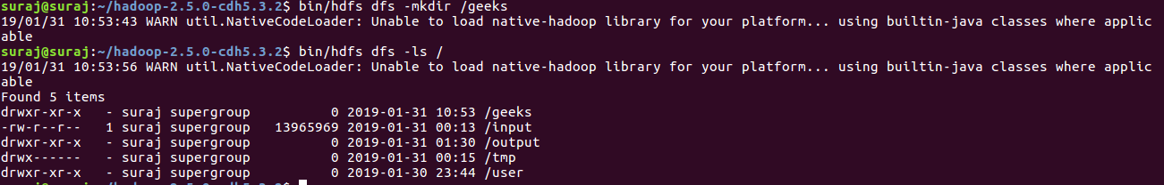

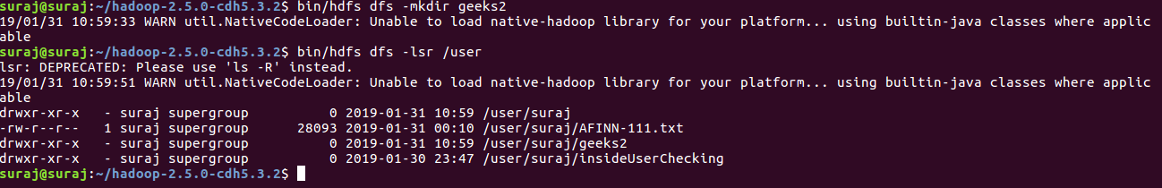

1. **touchz:**It creates an empty file.  
   Syntax:  
   bin/hdfsdfs -touchz  
   Example:  
   bin/hdfsdfs -touchz /geeks/myfile.txt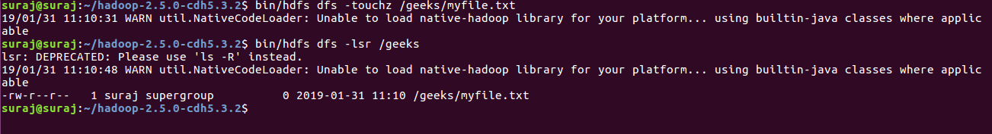
2. **copyFromLocal (or) put:** To copy files/folders from local filing system to hdfs store. this is often the foremost important command. Local filesystem means the files present on the OS.

Syntax:

bin/hdfsdfs -copyFromLocal

Example: Let’s suppose we've a file AI.txt on Desktop which we would like to repeat to folder geeks present on hdfs.

bin/hdfsdfs -copyFromLocal ../Desktop/AI.txt /geeks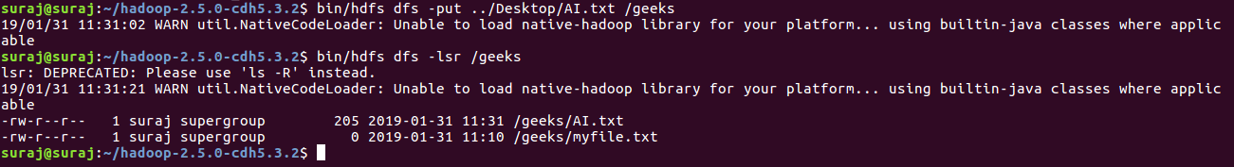

1. **cat:** To print file contents.

Syntax:

bin/hdfsdfs -cat <path>

Example:

// print the content of AI.txt present

// inside geeks folder.

bin/hdfsdfs -cat /geeks/AI.txt ->



1. **copyToLocal (or) get:** To copy files/folders from hdfs store to local file system.

Syntax:

bin/hdfsdfs -copyToLocal<<srcfile(on hdfs)><local file dest>

Example:

bin/hdfsdfs -copyToLocal /geeks ../Desktop/hero

(OR)

bin/hdfsdfs -get /geeks/myfile.txt ../Desktop/hero

myfile.txt from geeks folder will be copied to folder hero present on Desktop.



1. **moveFromLocal:** This command will move file from local to hdfs.

Syntax:

bin/hdfsdfs -moveFromLocal<local src><dest(on hdfs)>

Example:

bin/hdfsdfs -moveFromLocal ../Desktop/cutAndPaste.txt /geeks

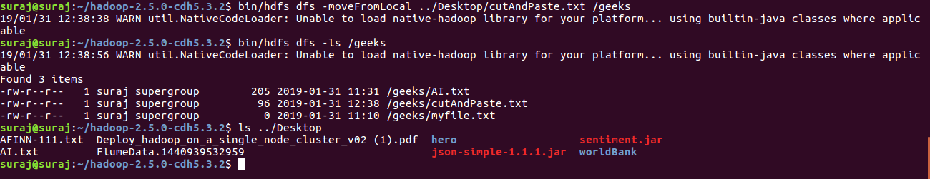

1. **cp:**This command is used to copy files within hdfs. Lets copy folder *geeks*to *geeks_copied*.

Syntax:

bin/hdfsdfs -cp <src(on hdfs)><dest(on hdfs)>

Example:

bin/hdfs -cp /geeks /geeks_copied

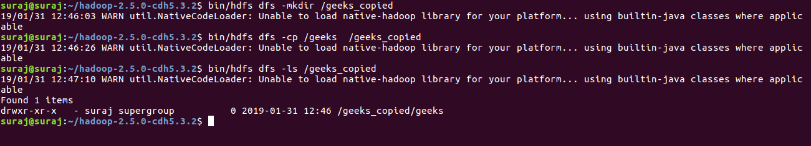

1. **mv:** This command is used to move files within hdfs. Lets cut-paste a file *myfile.txt* from *geeks*folder to *geeks_copied*.

Syntax:

bin/hdfsdfs -mv <src(on hdfs)><src(on hdfs)>

Example:

bin/hdfs -mv /geeks/myfile.txt /geeks_copied

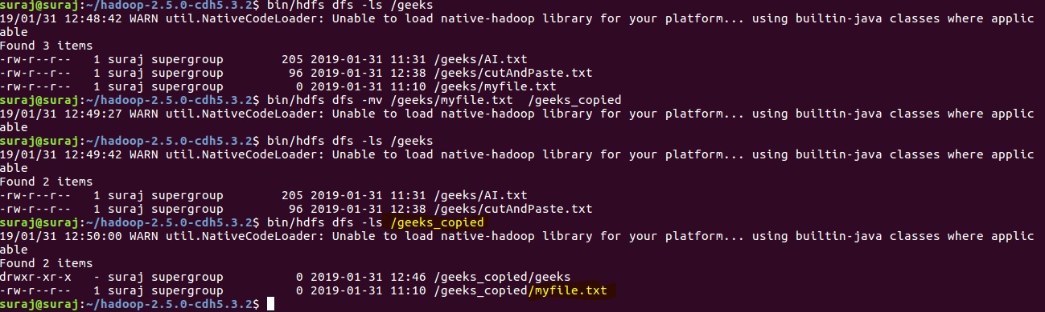

1. **rmr:** This command deletes a file from HDFS *recursively*. It is very useful command when you want to delete a *non-empty directory*.

Syntax:

bin/hdfsdfs -rmr<filename/directoryName>

Example:

bin/hdfsdfs -rmr /geeks_copied -> It will delete all the content inside the directory then the directory itself.

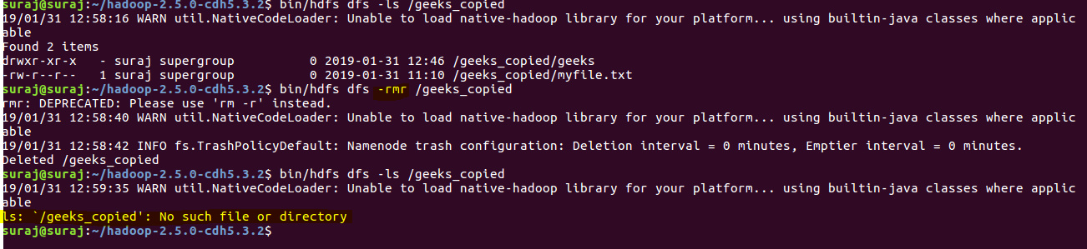

**Practical 3**

**Aim: To implement basic functions and commands in R Programming. To build Word Cloud, a text mining method using R for easy to understand and better visualization than a data table.**

Text Mining is one of the most critical ways of analysing and processing unstructured data which forms nearly 80% of the world’s data. Today most organizations and institutions gather and store massive amounts of data in data warehouses, and cloud platforms and this data continues to grow exponentially by the minute as new data comes pouring in from multiple sources.

As a result, it becomes a challenge for companies and organizations to store, process, and analyse vast amounts of textual data with traditional tools. This is where text mining applications, text mining tools, and text mining techniques come in.

Text mining incorporates and integrates the tools of information retrieval, data mining, machine learning, statistics, and computational linguistics, and hence, it is nothing short of a multidisciplinary field. Text mining deals with natural language texts either stored in semi-structured or unstructured formats.

**There are 5 major steps to create word clouds in R**

**Step 1: Create a text file**

In the following examples, we will process the “**I have a dream speech**” from “**Martin Luther King**” but you can use any text you want:

* Copy and paste the text in a plain text file (e.g.: ml.txt)
* Save the file

**Step 2: Install and Load the required packages.**

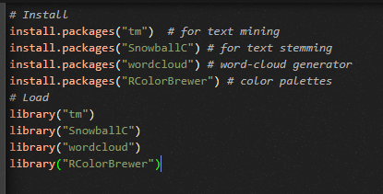

**Step 3: Text Mining**

**Load the text**

The text is loaded using **Corpus ()** function from **text mining** (tm) package. Corpus is a list of a document (in our case, we only have one document).

1. **We start by importing the text file created in Step 1**

To import the file saved locally in your computer, type the following R code. You will be asked to choose the text file interactively.



In the example below, I’ll load a .txt file hosted on STHDA website:

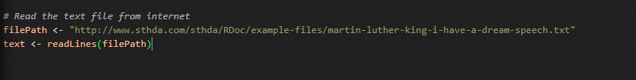

1. Load the data as a corpus.



1. Inspect the content of the document.



Text Transformation

Transformation is performed using **tm_map()** function to replace, for example, special characters from the text.

Replacing “/”, “@” and “|” with space:

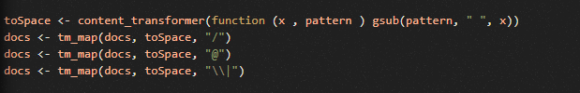

Cleaning the text

the **tm_map()** function is used to remove unnecessary white space, to convert the text to lower case, to remove common stop words like ‘the’, “we”.

The information value of ‘stop words’ is near zero due to the fact that they are so common in a language. Removing this kind of words is useful before further analyses. For ‘stop words’, supported languages are danish, Dutch, English, finnish, French, German, Hungarian, Italian, Norwegian, Portuguese, Russian, Spanish and Swedish. Language names are case sensitive.

Another important pre-processing step is to make a **text stemming** which reduces words to their root form. In other words, this process removes suffixes from words to make it simple and to get the common origin. For example, a stemming process reduces the words “moving”, “moved” and “movement” to the root word, “move”.

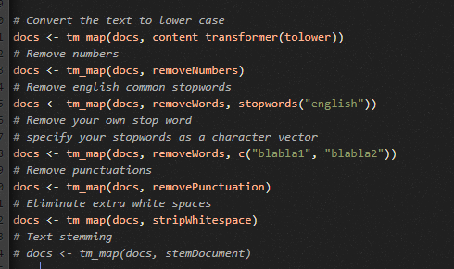

**Step 4: Build a term – document matrix**

Document matrix is a table containing the frequency of the words. Column names are words and row names are documents. The function TermDocumentMatrix() from **text mining** package can be used as follow :

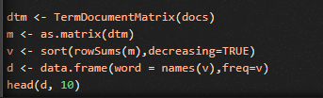

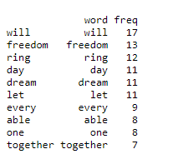

**Step 5: Generate the word cloud**





The above **word cloud** clearly shows that “Will”, “freedom”, “dream”, “day” and “together” are the five most important words in the “**I have a dream speech**” from **Martin Luther King**.

**Practical 4**

**Aim: To implement a word count application using the MapReduceprogramming model.**

Wordcount may be a simple program which counts the number of occurrences of every word during a given text input file set.

Wordcount fits alright with the MapReduce programming model making it an excellent example to know the Hadoop Map/Reduce programming style. Our implementation consists of three main parts:

1. Mapper 2. Reducer 3. Driver

**Step 1: Write a Mapper**

A Mapper overrides the “map” function from the category "org.apache.hadoop.mapreduce.Mapper" which provides pairs because the input. A Mapper implementation may output pairs using the provided Context.

Input value of the Wordcount Map task are going to be a line of text from the input file and therefore the key would be the road number. Map task outputs for every word within the line of text.

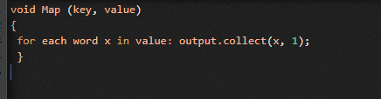

**Step 2: Write a Reducer**

A Reducer collects the intermediate output from multiple map tasks and assemble one result. Here, the Wordcount program will sum up the occurrence of every word to pairs as.



**Step 3: Write Driver**

The Driver program configures and run the MapReduce job. We use the most program to perform basic configurations such as:

* Job Name: name of this Job
* Executable (Jar) Class: the most executable class. For here, WordCount.
* Mapper Class: class which overrides the "map" function. For here, Map.
* Reducer: class which override the "reduce" function. For here, Reduce.
* Output Key: sort of output key. For here, Text.
* Output Value: sort of output value. For here, IntWritable.
* File Input Path
* File Output Path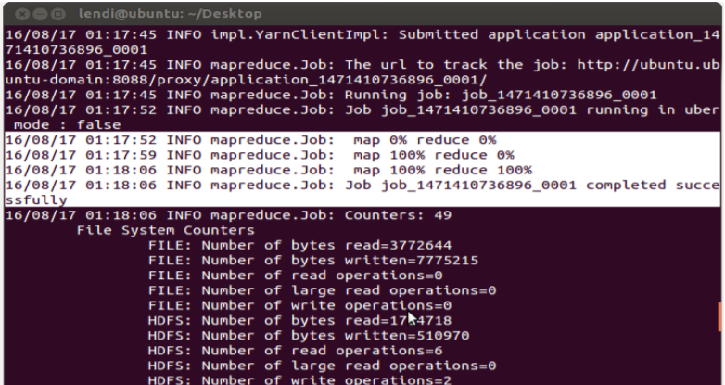

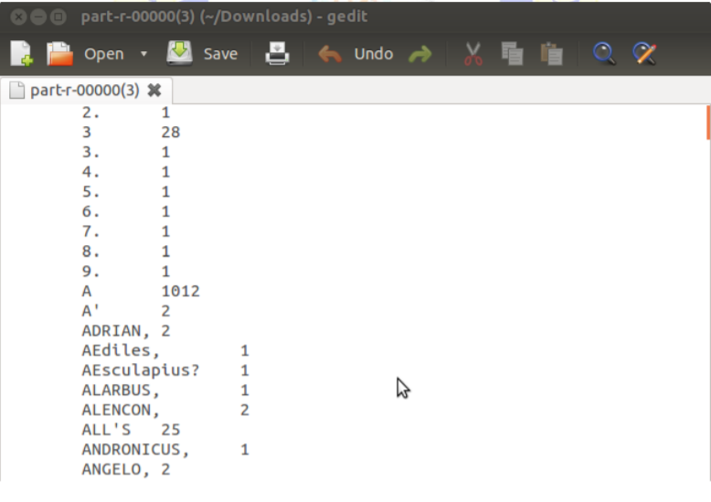

**PRACTICAL 5**

**Aim: To design and implement MapReduce algorithms to take a very large file of integers and produce as output:**

**a) The largest integer**

**b) The average of all the integers.**

**c) The same set of integers, but with each integer appearing only once.**

**d) The count of the number of distinct integers in the input.**

**Implementation:**

1. Largest Number

map(file_id,iterator numbers){

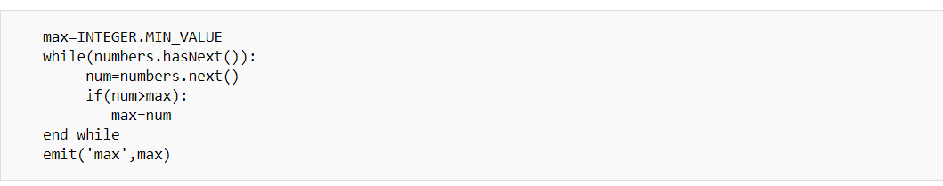

**}**

reduce(key, iterator max_values){

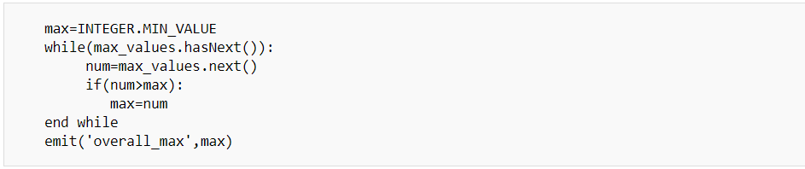

**}**

We are given an inventory of files and every file has list of numbers. In MapReduce, each node parallelly picks a file and executes map function by passing file_num as key and list of integers within the file as iterator. map function then finds the utmost therein file. then the map function maps the utmost of that file with the key 'max' and emits to the map-reduce framework which distributes the key-value pair to the network of nodes reduce function recieves single key 'max' and an inventory of maximum values. the weather of max_values are maximum of every file. Then reduce function finds the utmost among the max_values.

2. Average :

map(file_id,iterator numbers){

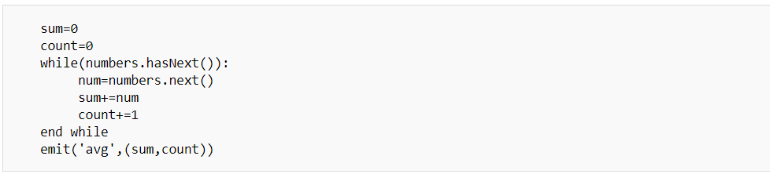

}

1. here the output is a tuple of sum and count as (sum,count)

reduce(key, iterator sum_count_tuples){

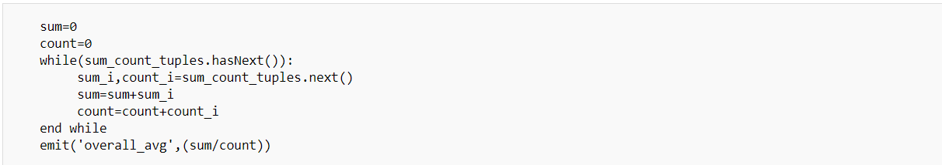

}

3.Same set of integers:

The same set of integers, but with each integer appearing just one occasion

Here we will just use the key as a filter:

Map: Take inputs and for every input return key=input, value=input.

Reduce: The list of keys is that the desired output.

4. Distinct:

map(file_id,iterator numbers){

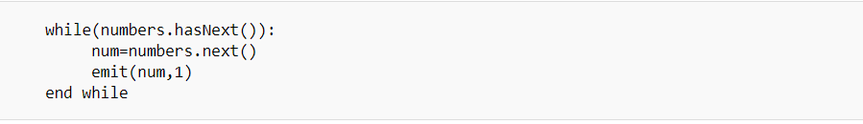

}

1. in map-reduce , emit is not return operation , it emits the key,value to network, so it can be inside loop
2. here number is the key

reduce(uniq_num, iterator values){



}here the values is list of 1s as [1,1,1,...1] for each unique number. so the emit in reduce produces 1 for each unique number. uniq_num is key.

**Practical 6**

**Aim: To implement basic CRUD operations (create, read, update, delete) in MongoDB and Cassandra.**

Atlas-managed MongoDB deployments, or “clusters”, can be either a replica set or a sharded cluster. This tutorial walks you through creating a replica set.

To implement CRUD operation in MongoDB, we need to create a cluster. To create cluster, follow the below steps…

1. Navigate to the Clusters page for your project
2. Open the Create New Cluster Dialog
3. Select a cluster type
4. Select your preferred Cloud Provider & Region
5. Select the Cluster Tier
6. Select any Additional Settings
7. Enter the Cluster Name
8. Deploy your Cluster



To access a cluster, we must create a MongoDB User with access to the desired database(s) on your Atlas cluster. MongoDB users are separate from Atlas users. MongoDB users have access to MongoDB databases, while Atlas users have access to the Atlas application itself.

To connect dialog to Connect to our cluster

1. Open the Connect dialog
2. Choose how you want to limit connections to your cluster
3. Create a Database User
4. Select your preferred connection method





1. Now, we can access the database using PowerShell.

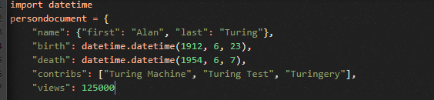



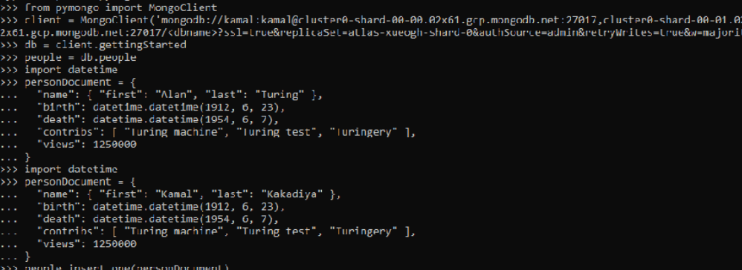

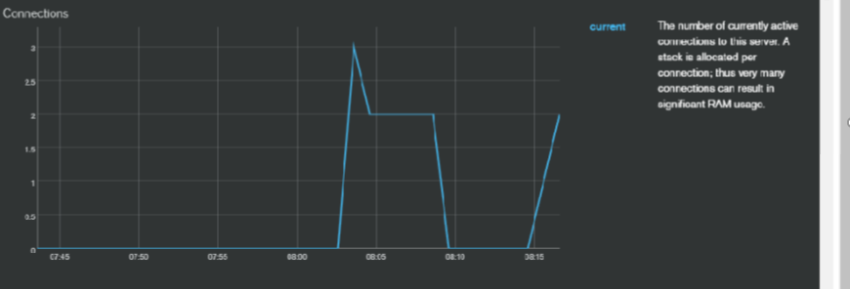

**Practical 7**

**Aim: To develop a MapReduce application and implement a program that analyses weather data.**

**Implementation:**

**Step 1: Download the weather dataset**

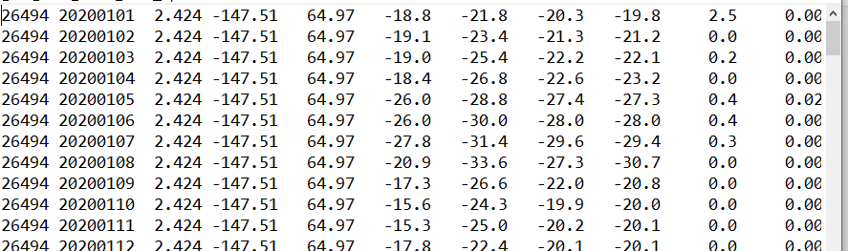

Columns 6 and 7 is showing Maximum and minimum temperature.

**Step 2: Make a project in Eclipse**

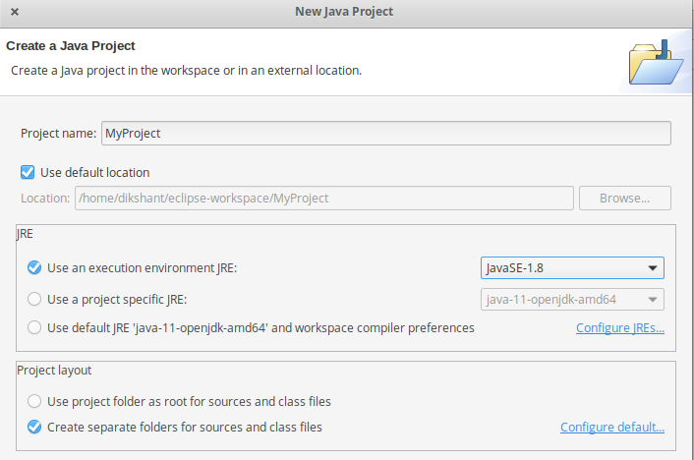

**Code:**

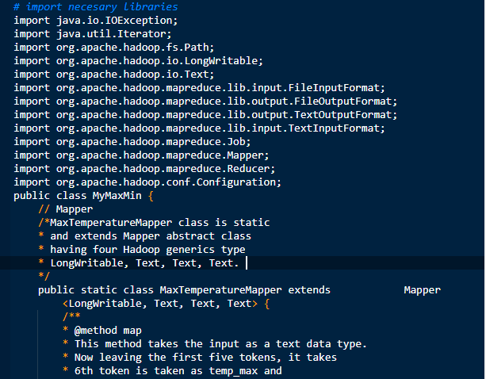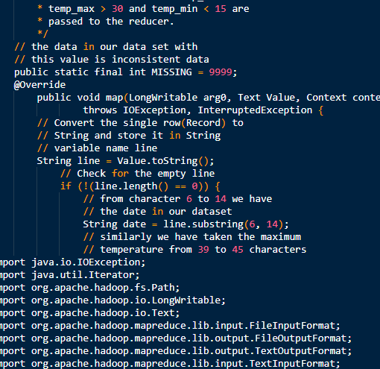

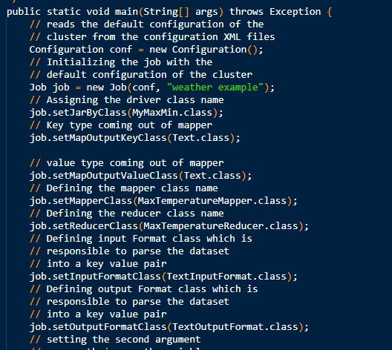

Now, export the project as jar file, and choose main class as Mymaxmin

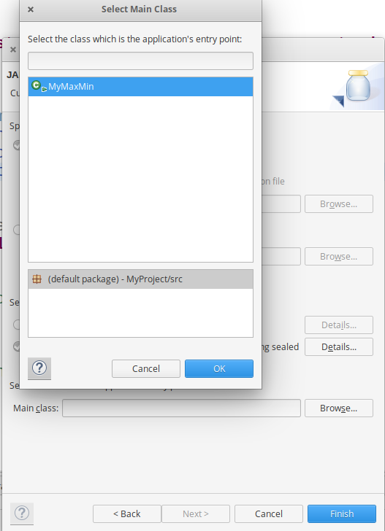

**Start our Hadoop Daemons**

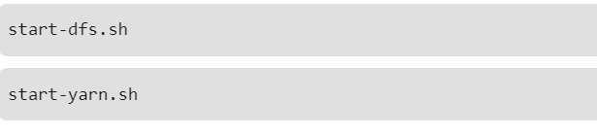

**Move your dataset to Hadoop HDFS**

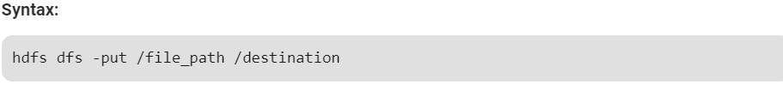

In below command **/** shows the root directory of our HDFS.



Check the file sent to our HDFS.



**Run the jar file with below command and produce the output ion MyOutput File**

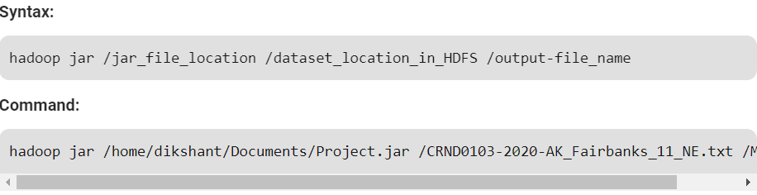

**Switch to localhost:50070/**, under utilities, pick Search the file system and download part-r-00000 from the / MyOutput directory to see the outcome.

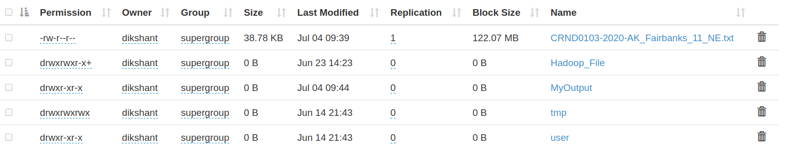

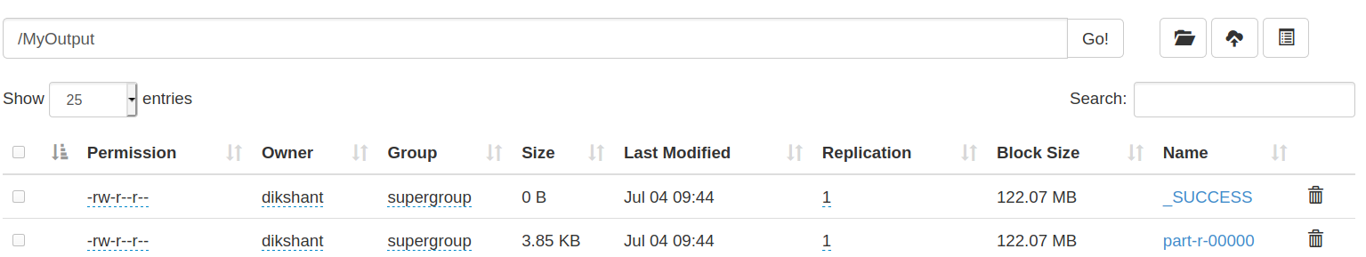

**Result in the downloaded File.**

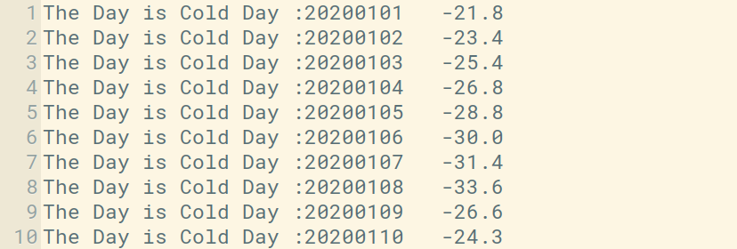

In the picture above, you can see the top 10 findings representing the cold days. The second column is a day in Yyy / mm / dd format. For eg, 20200101 shall mean

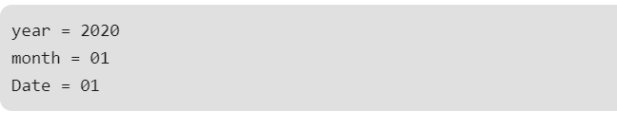

**Practical 8**

**Aim: To install and run HIVE. Use Hive to create, alter, and drop databases, tables, views, functions, and indexes. To create HDFS tables and load them in HIVE and implement joining of table in HIVE.**

**HIVE**

Apache **Hive** is an open source data warehouse software for reading, writing and managing large data set files that are stored directly in either the Apache **Hadoop** Distributed File System (**HDFS**) or other data storage systems such as Apache HBase.

1. **Download Hive**

https://archive.apache.org/dist/hive/hive-2.1.0/

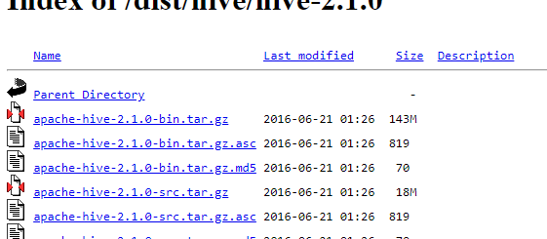

1. **Download Apache Derby**

[**https://archive.apache.org/dist/db/derby/db-derby-10.12.1.1/**](https://archive.apache.org/dist/db/derby/db-derby-10.12.1.1/)

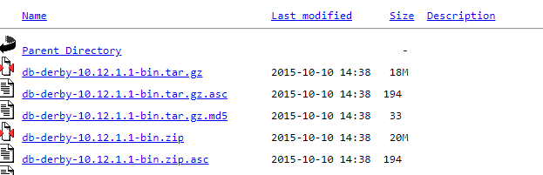

1. **Extract both the files**

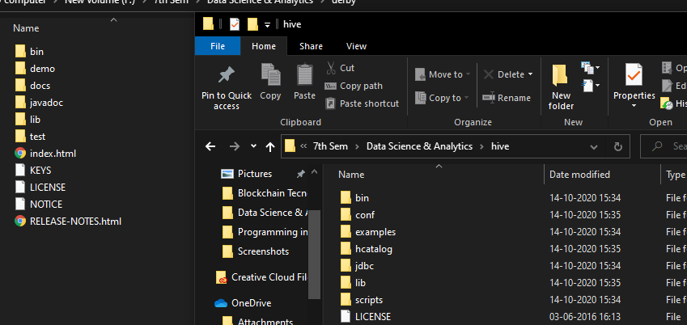

1. **Place hive – site.xml file in hive ->conf and then move both hive and derby folders to C drive**

[**https://drive.google.com/file/d/1qqAo7RQfr5Q6O-GTom6Rji3TdufP81zd/view**](https://drive.google.com/file/d/1qqAo7RQfr5Q6O-GTom6Rji3TdufP81zd/view)

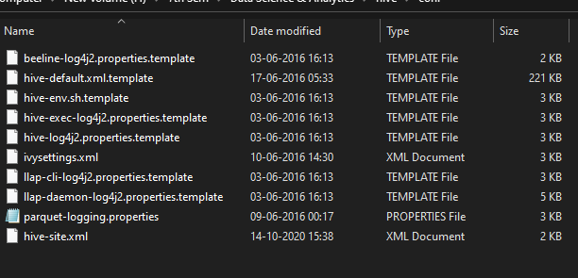

1. **Copy all the files from derby->lib and paste it to hive->lib**

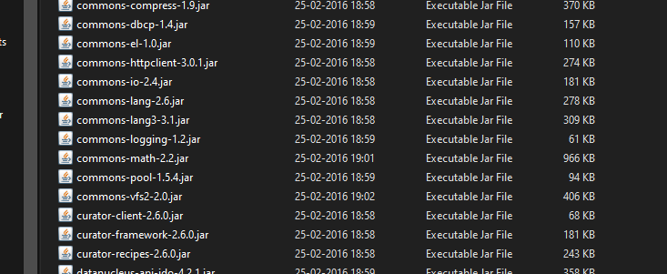

1. **Add a new variable in Environmental variables – hive home, hive bin, hive lib**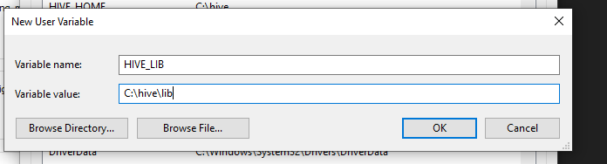

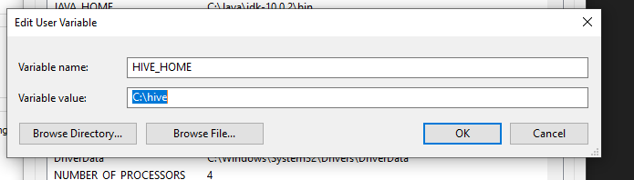

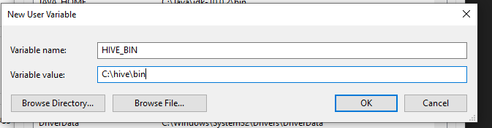

1. **Different configuration properties to be put in Apache Hive**

* We're going to do two things in this phase.

1. Placing the Hive Home route to the bashrc file
2. Placing the Hadoop Home path location in hive-config.sh
3. Mention Hive Pathin ~/.bashrc



* Open the bashrc file as shown in above screenshot
* Mention Hive home path i.e., HIVE_HOME path in bashrc file and export it as shown in below



Code in bashrc:

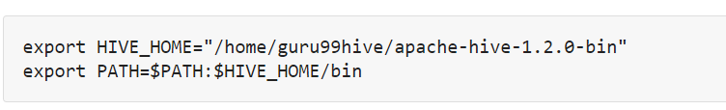

1. Exporting **Hadoop path in Hive-config.sh.Open the hive-config.sh**



1. **Creating Hive directories in Hadoop**

**To interact with Hadoop, we need to build directories in Hadoop as shown below.**



Giving root permissions to build Hive folders in Hadoop. If there is no error message, then this means that Hadoop has successfully issued permissions to Hive folders.



Getting into the Hive shell by entering it.' /hive 'command as shown below.

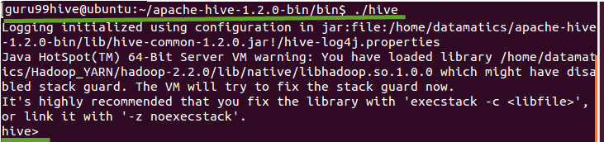

**SYNTAX for HIVE Database Operations:**

**DATABASE Creation**

CREATE DATABASE|SCHEMA [IF NOT EXISTS]

**Drop Database Statement**

DROP DATABASE StatementDROP (DATABASE|SCHEMA) [IF EXISTS] database_name [RESTRICT|CASCADE];

**Creating and Dropping Table in HIVE**

CREATE [TEMPORARY] [EXTERNAL] TABLE [IF NOT EXISTS] [db_name.] table_name [(col_namedata_type [COMMENT col_comment], ...)]

[COMMENT table_comment] [ROW FORMAT row_format] [STORED AS file_format]

**Loading Data into table log_data**

**Syntax:**

LOAD DATA LOCAL INPATH '/u.data' OVERWRITE INTO TABLE u_data;

**Alter Table in HIVE**

**Syntax**

ALTER TABLE name RENAME TO new_name

ALTER TABLE name ADD COLUMNS (col_spec[, col_spec ...])

ALTER TABLE name DROP [COLUMN] column_name

ALTER TABLE name CHANGE column_namenew_namenew_type

ALTER TABLE name REPLACE COLUMNS (col_spec[, col_spec ...])

**Creating and Dropping View**

REATE VIEW [IF NOT EXISTS] view_name [(column_name [COMMENT column_comment], ..) ] [COMMENT table_comment] AS SELECT

**Dropping View**

**Syntax:**

DROP VIEW view_name

**Functions in HIVE**

String Functions:- round(), ceil(), substr(), upper(), reg_exp() etc

Date and Time Functions:- year(), month(), day(), to_date() etc

Aggregate Functions :- sum(), min(), max(), count(), avg() etc

**INDEXES**

CREATE INDEX index_name ON TABLE base_table_name (col_name, ...)

AS 'index.handler.class.name'

[WITH DEFERRED REBUILD]

[IDXPROPERTIES (property_name=property_value, ...)]

[IN TABLE index_table_name]

[PARTITIONED BY (col_name, ...)]

[ [ ROW FORMAT ...] STORED AS ... | STORED BY ... ] [LOCATION hdfs_path] [TBLPROPERTIES (...)]

**Creating Index**

CREATE INDEX index_ip ON TABLE log_data(ip_address) AS org.apache.hadoop.hive.ql.index.compact.CompactIndexHandler' WITH DEFERRED REBUILD;

**Altering and Inserting Index**

ALTER INDEX index_ip_address ON log_dataREBUILD;

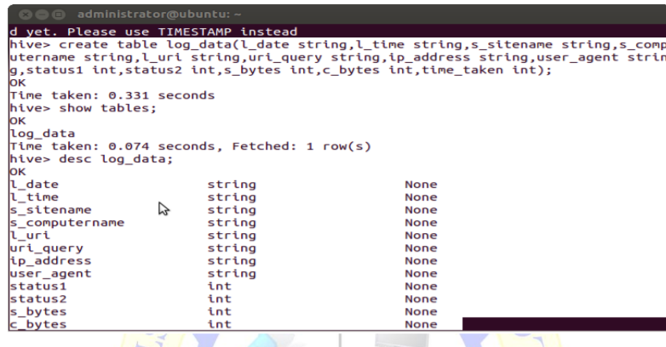

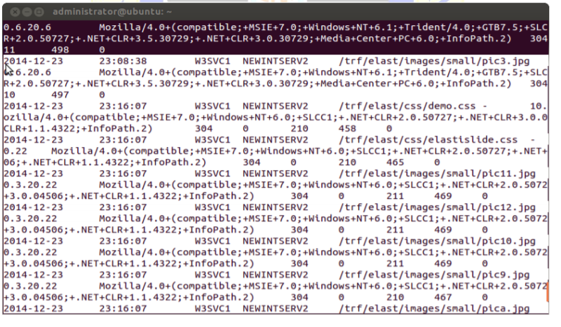

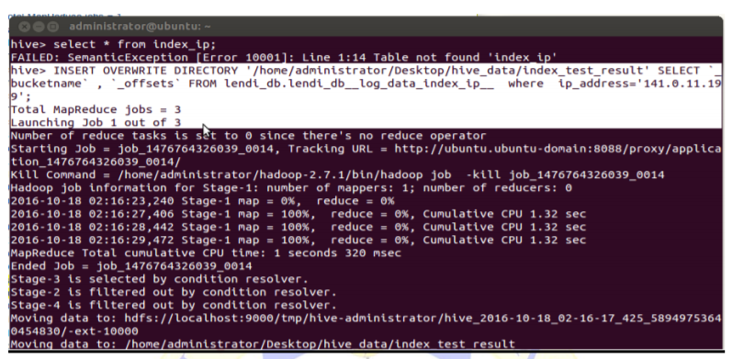

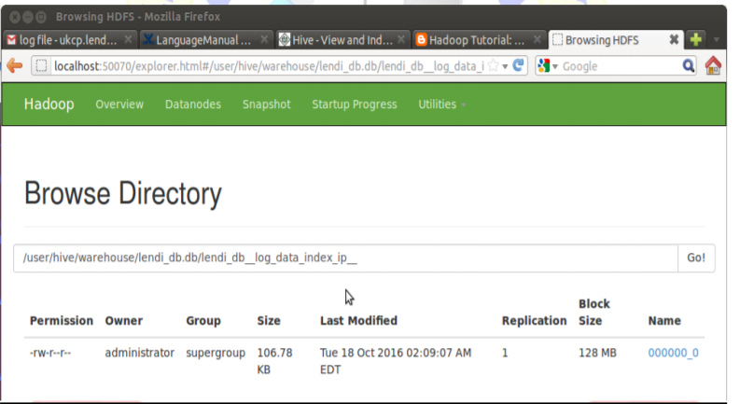

**PRACTICAL 9**

|  |
| --- |
| **Aim: To install and run Pig and then write Pig Latin scripts to sort, group, join, project, and filter your data.** |

**Implementation:**

Apache Pig is an abstraction of MapReduce. It is a tool / platform that is used to analyse larger data sets that represent them as data streams. Pig is commonly used in Hadoop; all data processing operations in Hadoop can be done using Apache Pig.

**Apache Pig – Installation**

Prerequisites: It is important that you have Hadoop and Java built on your device before you go to Apache Pig. Therefore, instal Hadoop and Java before installing Apache Pig by following the steps given in the following link:

<http://www.tutorialspoint.com/hadoop/hadoop_enviornment_setup.htm>

Download Apache Pig

First of all, download the latest version of Apache Pig from the following website − <https://pig.apache.org/>

**Step 1:** Open the website of Apache Pig. Under the News column, press the Link Release page as seen in the snapshot below.

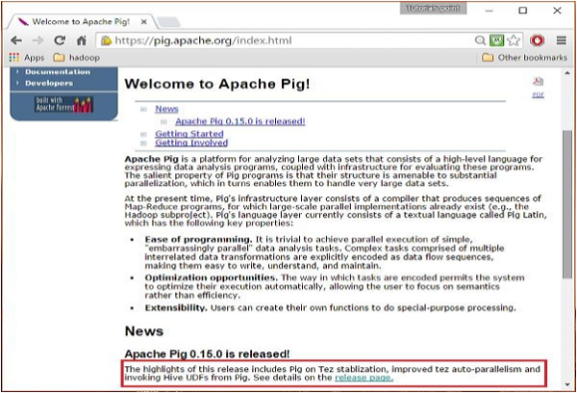

**Step 2:** You will be redirected to the Apache Pig Releases page when you click the link you specified. On this page, under the Download section, you will have two links, namely Pig 0.8 and later and Pig 0.7 and earlier. Click on the link Pig 0.8 and then you'll be redirected to a page with a set of mirrors.

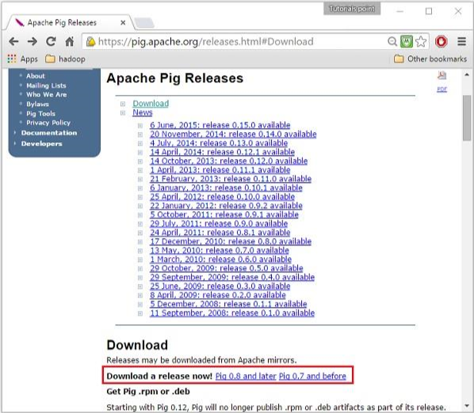

**Step 3:** Choose and click any one of these mirrors as shown below.

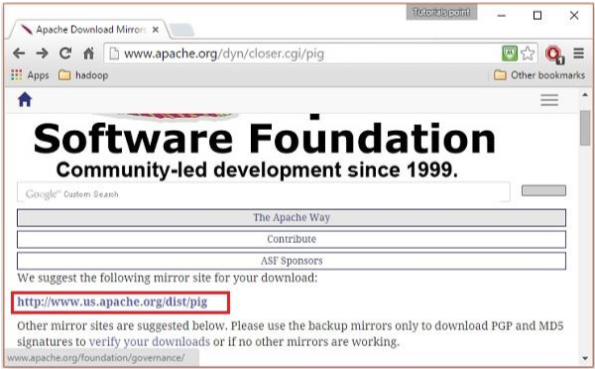

**Step 4:** These mirrors are going to take you to the Pig Releases tab. This page contains a number of versions of Apache Pig. Tap on the new update of this one.

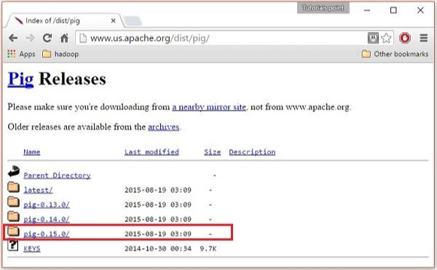

**Step 5:** In these directories, you can have the root and binary files of Apache Pig in different distributions. Download the root and binary tar files of Apache Pig 0.15, pig0.15.0-src.tar.gz and pig-0.15.0.tar.gz.

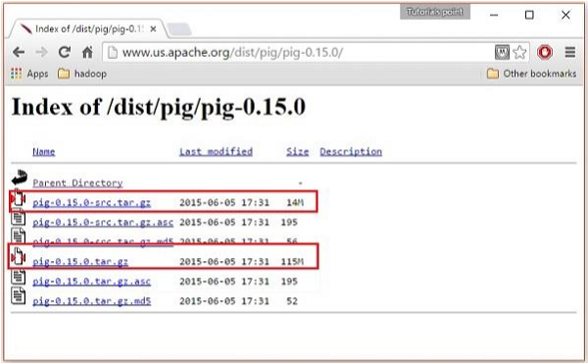

**Install Apache Pig**

After downloading the Apache Pig app, instal it in your Linux environment by following the steps below.

**Step 1:**

Create a directory named Pig in the same directory where Hadoop, Java, and other software installation directories have been installed. (We built the Pig directory in the user called Hadoop in our tutorial).

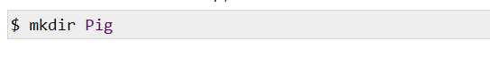

**Step 2:**

Extract the downloaded tar files as shown below.

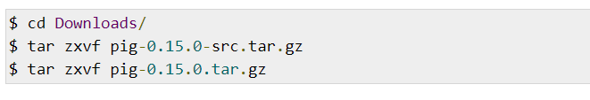

**Step 3:**

Move the content of pig-0.15.0-src.tar.gz file to the Pig directory created earlier as shown below.



|  |
| --- |
| **Pig Latin scripts** |
|  |

* **Sorting Data:**

SORT_DATA = ORDER DATA BY ATTRIBUTE WITH CONDITION;

* **GROUP:**

Data GDATA = GROUP DATA by ATTRIBUTE;

* **FILTER:**

Data FDATA = FILTER DATA by ATTRIBUTE = VALUE;

* **JOIN Data:**

JOIN DATA1 BY (ATTRIBUTE1, ATTRIBUTE2….), DATA2 BY (ATTRIBUTE3, ATTRIBUTE…. N)

**Practical 10**

**Aim: To install, deploy & configure Apache Spark Cluster. To Select the fields from the dataset using Spark SQL. To explore Spark shell and read from HDFS.**

**Implementation:**

Apache Spark is a lightning-fast cluster computing technology, designed for fast computation. It is based on Hadoop MapReduce and it extends the MapReduce model to efficiently use it for more types of computations, which includes interactive queries and stream processing. The main feature of Spark is its **in-memory cluster computing** that increases the processing speed of an application.

1. **Install Java:** [Java](https://www.tutorialkart.com/java-tutorials/) is the only dependency to be installed for Apache Spark.

To install Java, open a terminal and run the following command:

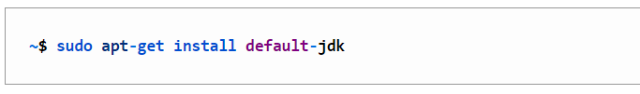

## Install latest Apache Spark on Ubuntu 16

1. **Download Spark:** There is a continuing progression of the Apache Spark. Newer models are starting to come out now and then. So, grab the new update of Spark when you're going to launch it. To download latest Apache Spark release, open the url [<http://spark.apache.org/downloads.html>] in a browser.

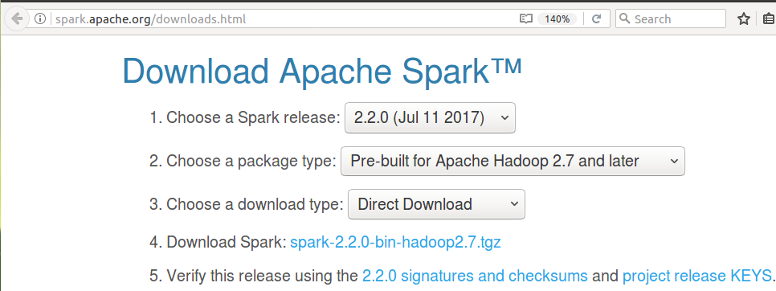

1. **Unzip and move spark to /usr/lib/:** Downloading is a zip drive. Unzip the file before setting up Apache Spark on your PC. To unzip the download, open the terminal and run the tar command from the zip file location.

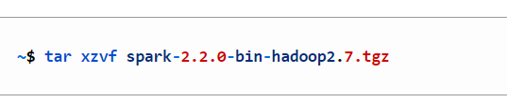

Move the folder to / usr / lib/. In the following terminal commands, we've copied the contents of the unzipped spark folder to a folder called spark. Then we moved the designated folder to / usr / lib/.

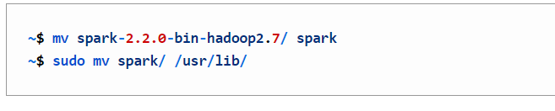

1. **Add Path:** We now need to set the SPARK HOME environment variable and add it to the Route. The JAVA HOME variable should also be configured as a prerequisite.To set the JAVA HOME variable and add the / usr / lib / spark / bin folder to PATH, open ~/.bashrc with any editor. We're using the nano editor here:

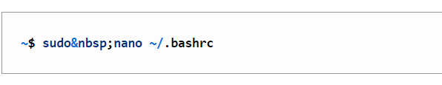

And add following lines at the end of ~/.bashrc file.

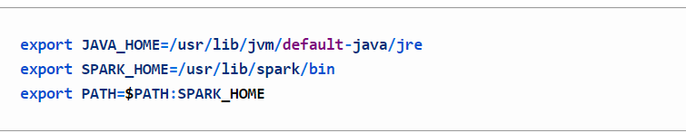

Latest Apache Spark is successfully installed in your Ubuntu 16.

1. **Verify installation:** Now that we've installed everything you need and set up the Route, we'll check if Apache Spark has been installed correctly. To check the installation, close the terminal that has already been opened and open the new terminal again. Run the following command as follows:

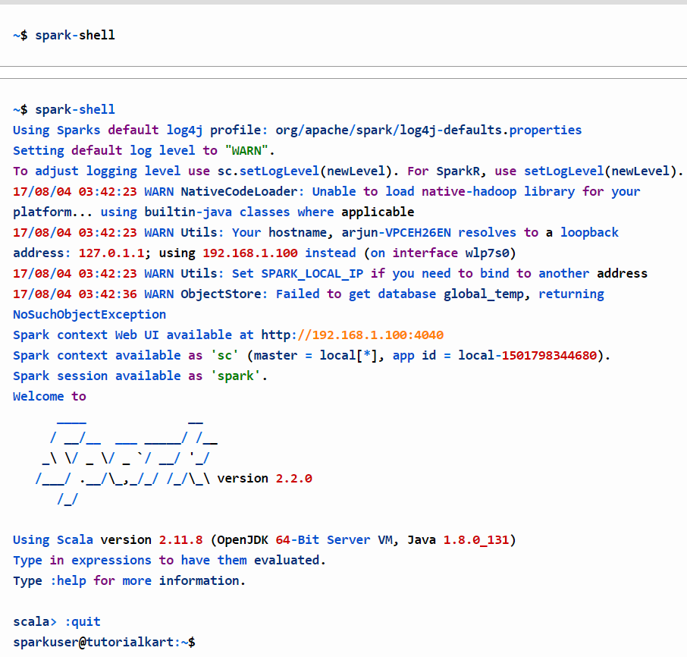

* Using the following steps to navigate the Spark SQL by using the Spark shell.

The following example command begins the Spark shell on the YARN cluster:



* Create a SQLContext to read data directly from the file system. For eg, which uses SQLContext and the Spark DataFrame API to access the JSON file.
* To read data by interacting with the Hive Metastore, construct a HiveContext instance (HiveContext extends SQLContext).

**Practical 11**

**Aim: To perform PYspark shell exploration and reading and writing in HDFS. To perform Sentiment Analysis and use Scala.**

**Implementation:**

### **Reading data**

**Code:**

from pyspark import SparkConf, SparkContext

import sys

conf = SparkConf().setMaster("local").setAppName("RatingsHistogram")

sc = SparkContext(conf = conf)

*# Create a hardcoded RDD*

numbers = sc.parallelize([1, 2, 3, 4])

*# Load plain text files (e.g. CSVs) from different sources*

hdfs_lines = sc.textFile("hdfs:///user/cloudera/ml-100k/u.data", minPartitions=1)

local_lines = sc.textFile("file:///home/alex/ml-100k/u.data")

s3_lines = sc.textFile("s3n://bucket/ml-100k/u.data")

CLI_arg_lines = sc.textFile(sys.argv[1])

*# Create RDDs from an existing Hive repository*

hive_ctx = HiveContext(sc)

hive_lines = hive_ctx.sql("SELECT name, age FROM users WHERE age > 18")

* Notice that this can not be run with the standard Python interpreter. Instead, you use the spark-submit to submit it as a batch task, or name the Shell Pyspark.

**Writing of data:**

* The RDD class has the method saveAsTextFile. However, this saves the representation of each variable in a string. In Python, the resulting text file will contain lines such as (1949, 111).
* If you want to save the data in CSV or TSV format, you can either use Python's StringIO and csv modules or simply map each variable (vector) into a single string, e.g. as follows:

**Code:**

res.saveAsTextFile("hdfs:///user/cloudera/res_raw.txt") *# bad format*

res.map(lambda row: str(row[0]) + "\t" + str(row[1])) \

.saveAsTextFile("hdfs:///user/cloudera/res_tsv.txt") *# good format*

**Sentiment Analysis using Scala:**

**Spark Streaming Implementation:**

**Code:**

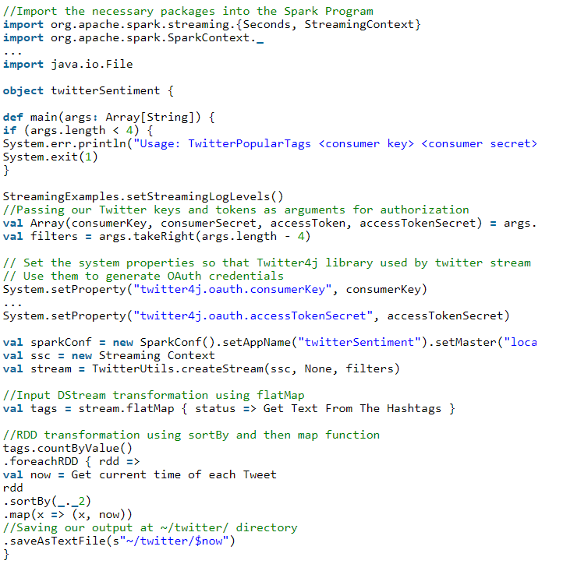

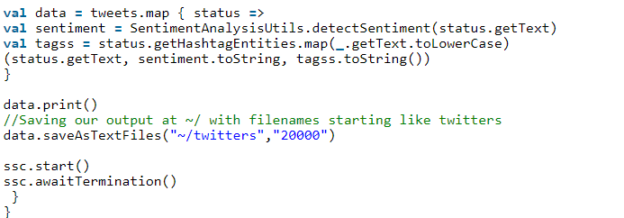

**Results:**

The following are the results shown in the Eclipse IDE when running the Twitter Sentiment Streaming software.

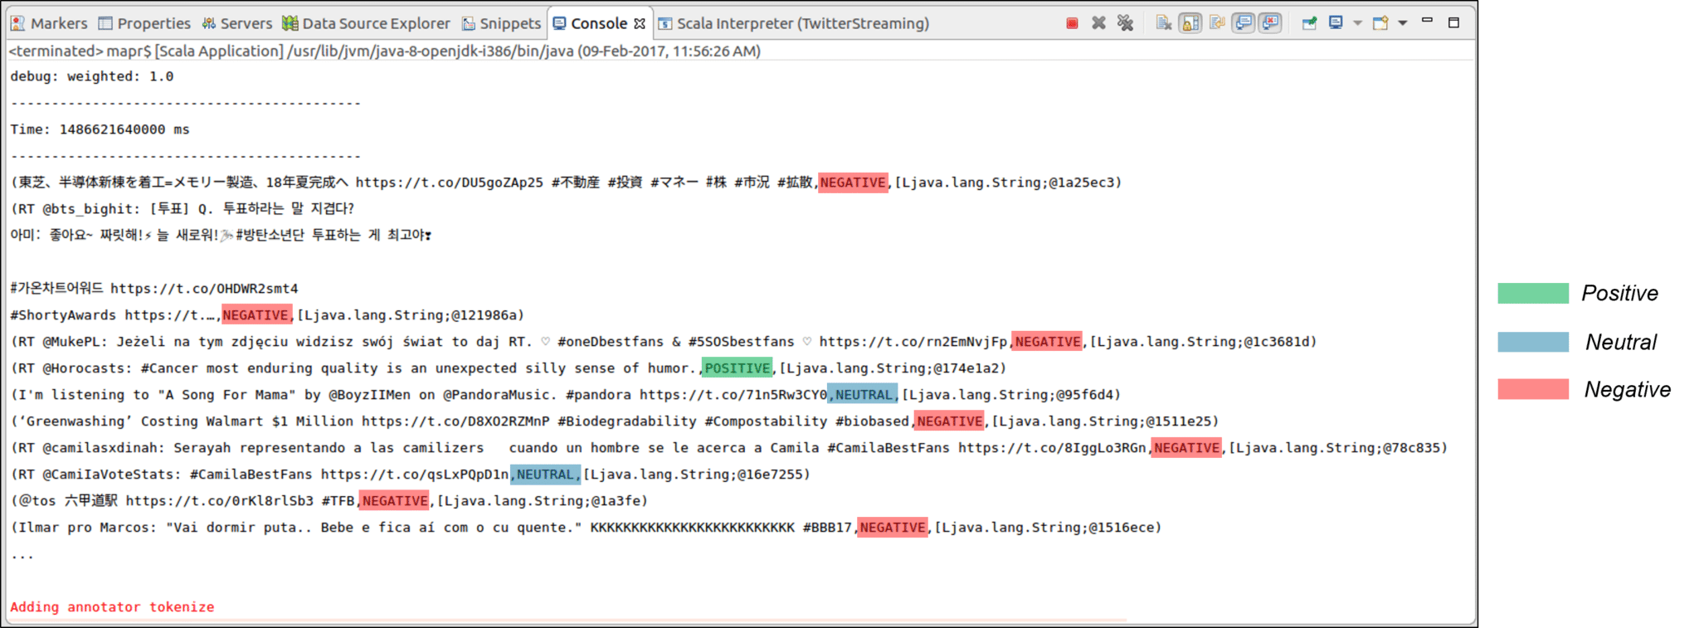

* As we can see from the screenshot, all tweets are categorised as Positive, Neutral and Negative according to the feelings of the contents of the tweets.
* The output of the Sentiments of the Tweets is stored in folders and files, depending on the time they were created. This output can be stored on the local file system or HDFS as appropriate. The output directory looks like this one:

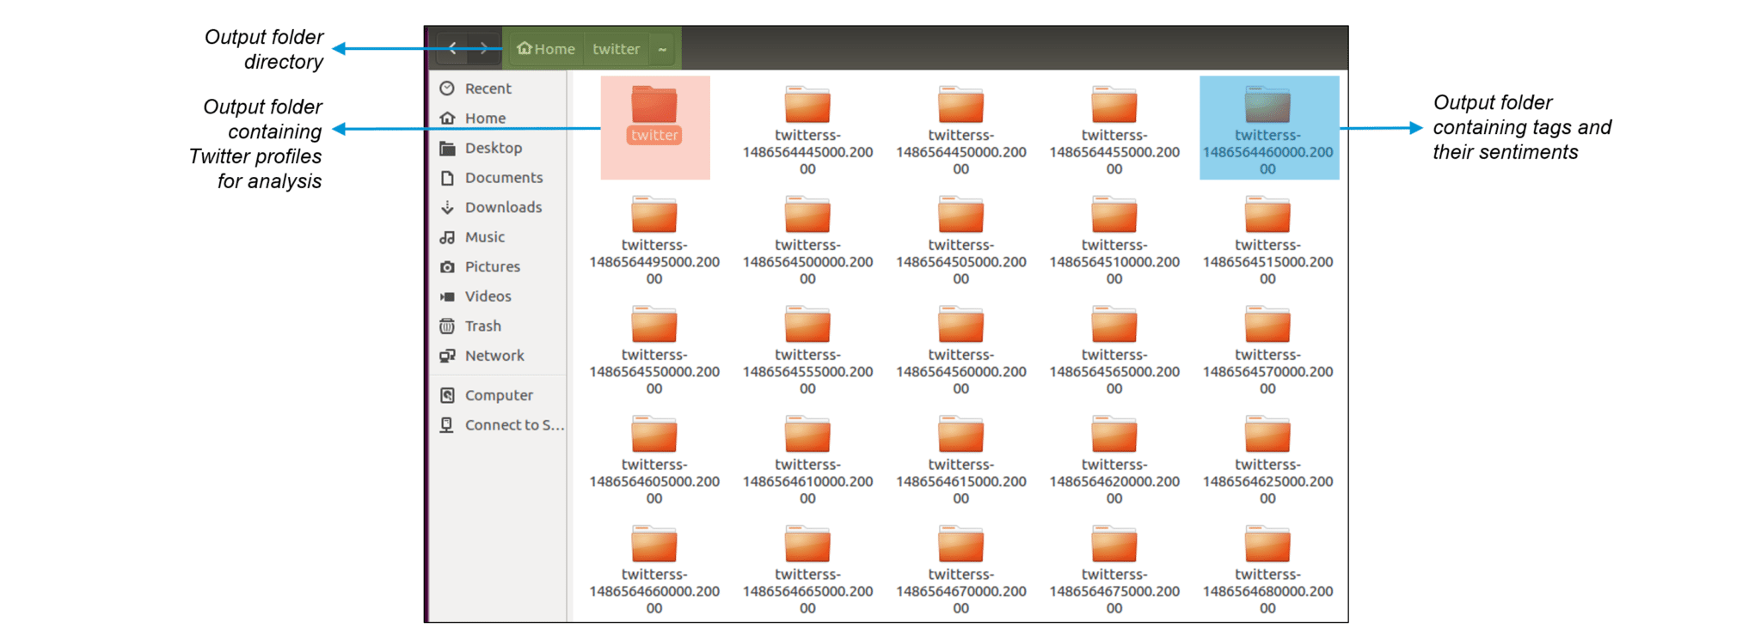

* Here, within the twitter folders, we will find the usernames of the Twitter users and the timestamp for. tweet as seen below:

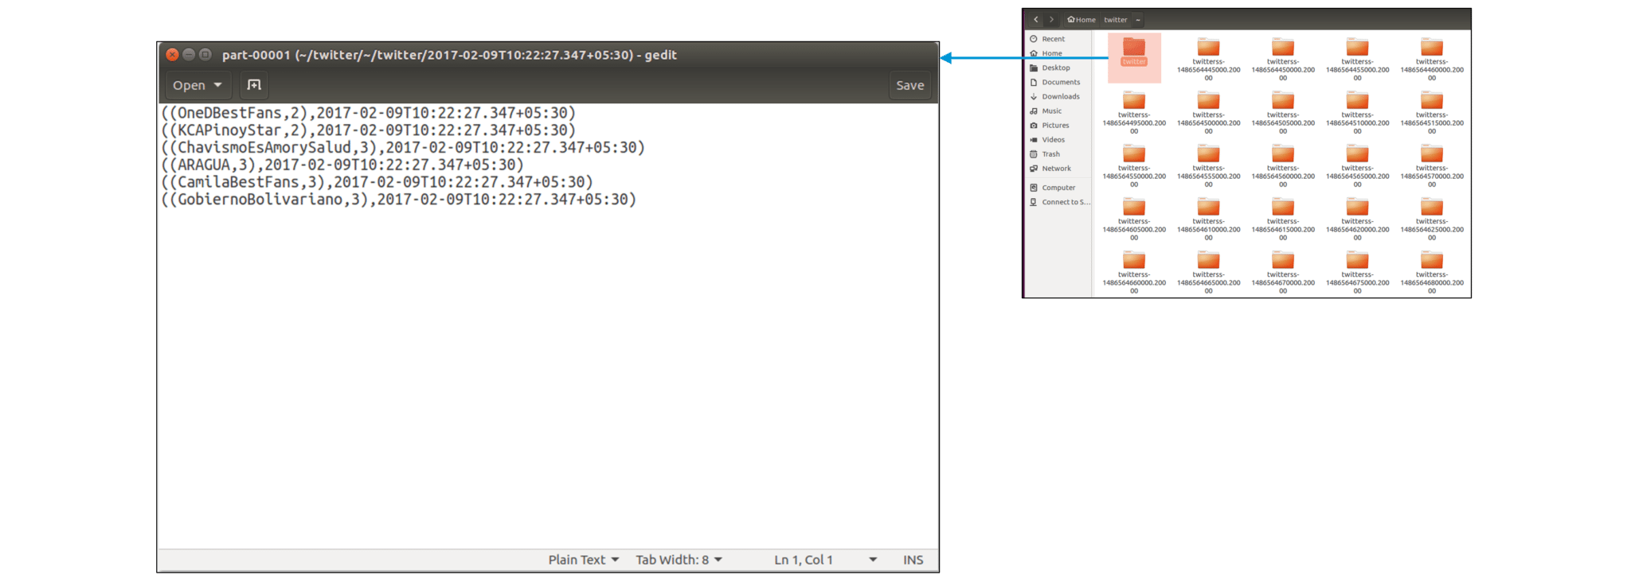

* Now that we have Twitter usernames and timestamps, let 's look at the Sentiments and Tweets saved in the main directory. Here, every tweet is accompanied by a feeling of emotion. This Sentiment, which is processed, is further used to examine a broad variety of business observations.

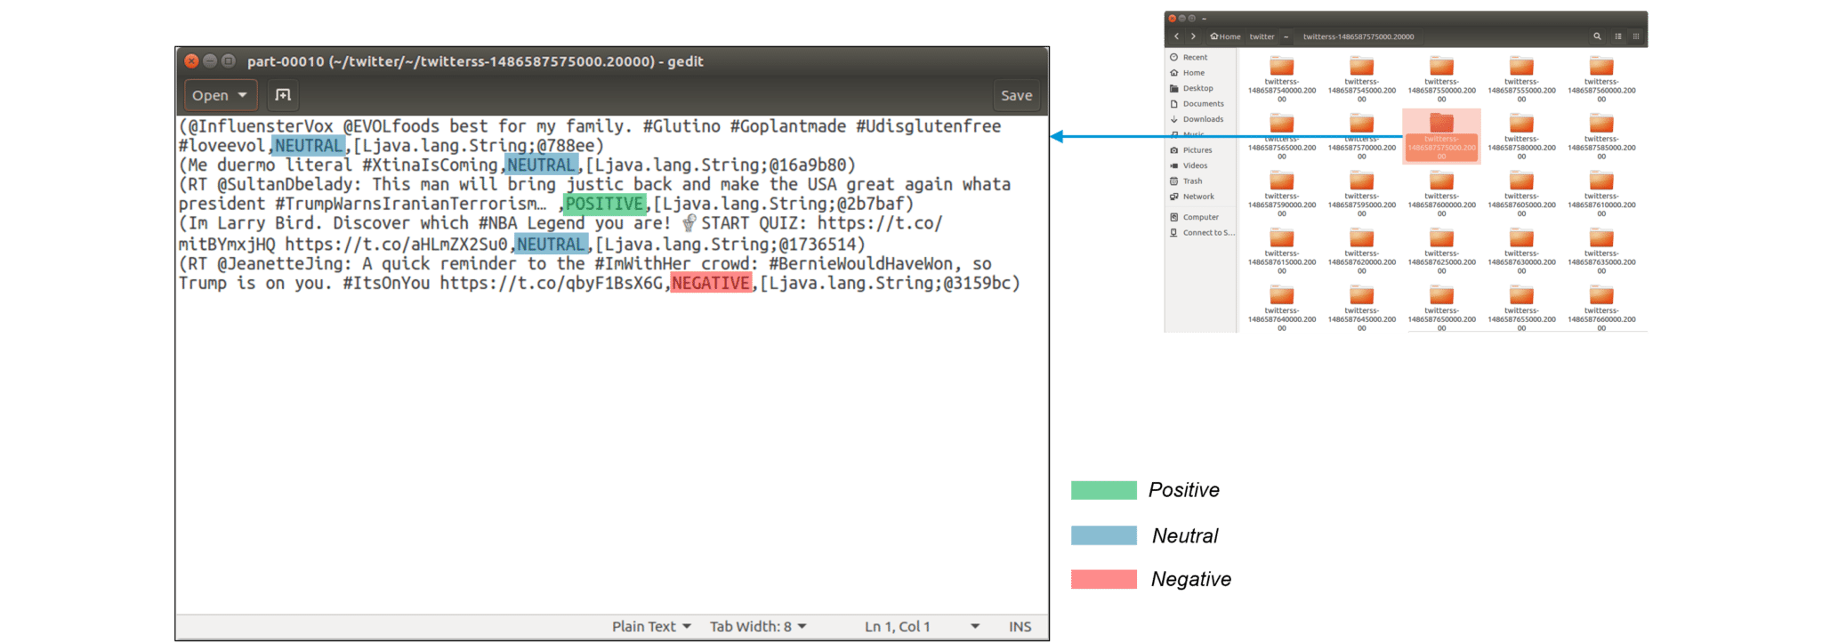

* Tweaking Code: Now, let's modify our code a little to get feelings about specific hashtags (topics). Donald Trump, the President of the United States, is now travelling through television outlets and online social media. Let us look at the emotions associated with the keyword 'Trump.'

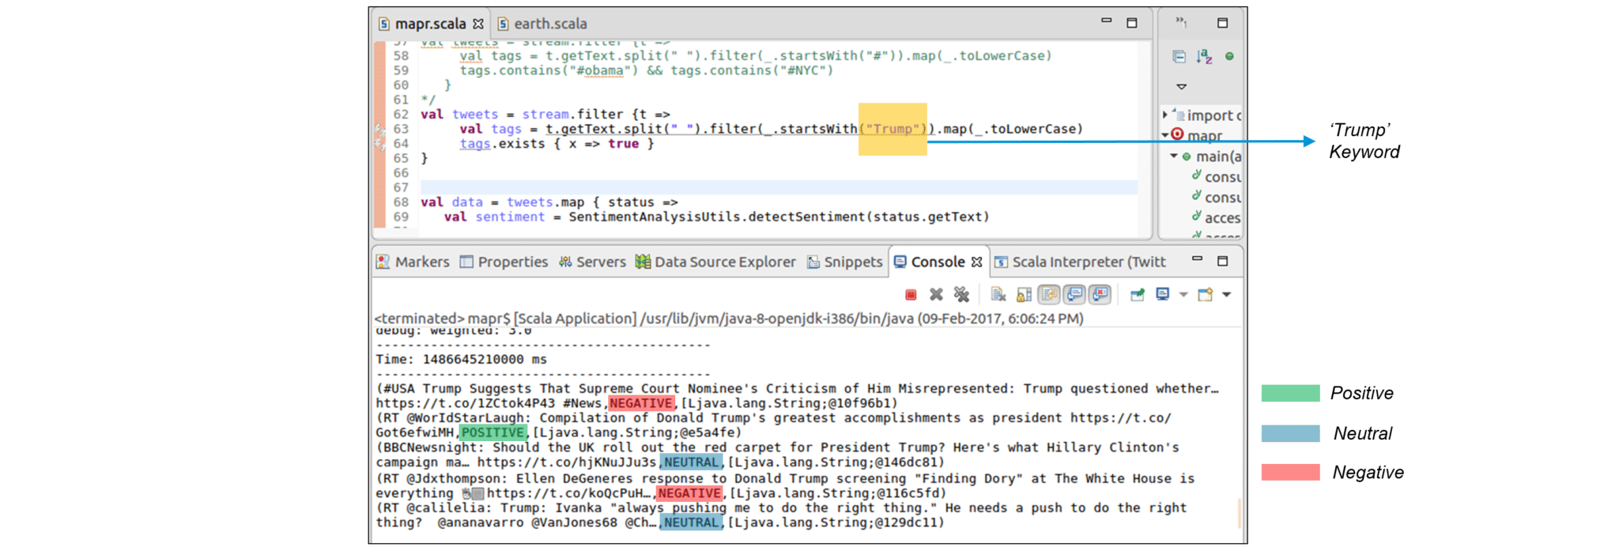

**Practical 12**

**Aim: To perform Graph analytics and visualization using Neo4j and Gephi**

**Implementation:**

## [Creating a Graph Visualization from Neo4j Data](https://www.yworks.com/pages/visualizing-a-neo4j-graph-database#creating-a-graph-visualization-from-neo4j-data)

* Visualization allows users to creatively explore stored data, to recognise important structures, and to achieve a deeper understanding of relationships.
* In addition to visual experimentation, it is often possible to communicate with stored data by changing the diagram without any Cypher expertise that helps non-technical users to explore and change the data.
* For example, with mouse gestures, new nodes and relationships can be created. Visualizing a graph database is therefore a powerful solution when handling or analysing large amounts of data.

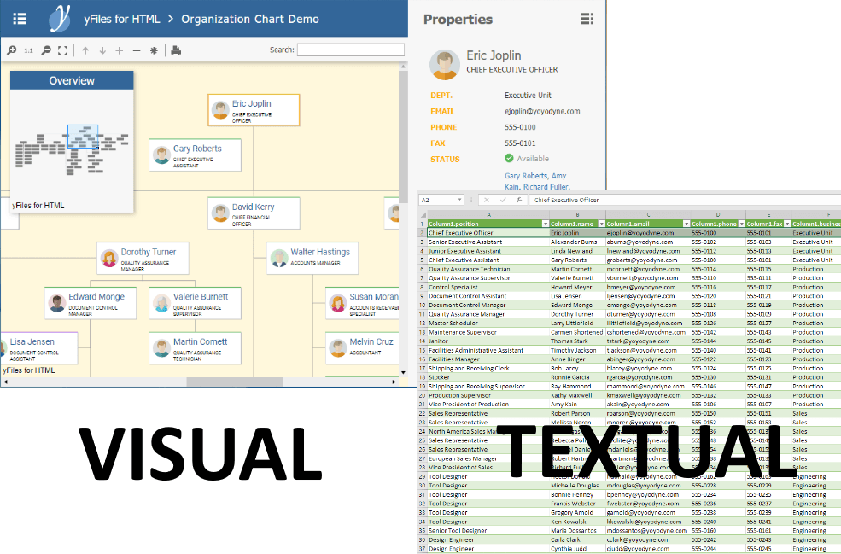

* Neo4j comes with an advanced analysis tool. This tool lets you run Cypher queries and shows the response either as a table or as a plain, force-based diagram. Although this is useful for learning Cypher and as a simple check whether a question yields the correct answer, more complicated tasks also need sophisticated and personalised visualisation.

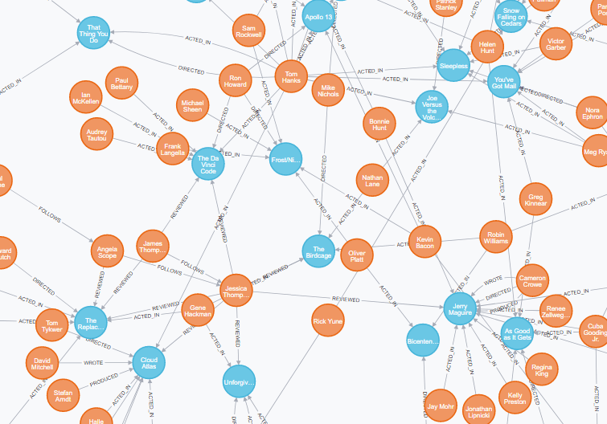

### [**Data-Driven Visualization**](https://www.yworks.com/pages/visualizing-a-neo4j-graph-database#data-driven-visualization)

* Good visualisation offers insights into data that are not apparent from looking at raw data. YFiles for HTML provides a variety of ways to use Neo4j database data to construct a rich and meaningful representation. Users can take advantage of powerful data linking capabilities to build object models that use the labels and properties of Neo4j data.

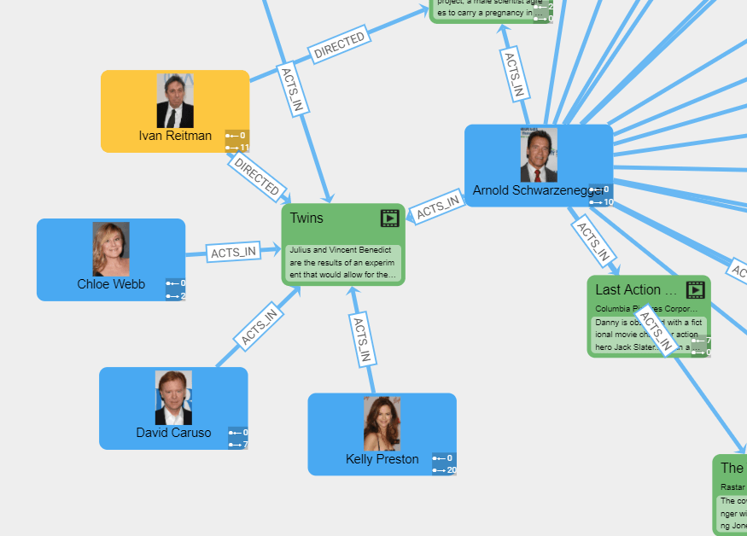

# **Visual network analysis with Gephi**

* Gephi is a piece of open-source software that lets you simulate, control, and discover the network.
* Networks (a.k.a. graphs) can be stored in a variety of file formats (for example. gexf, gdf, or. gml) Nodes and edges can represent any kind of entity and relationship.
* In the screenshot below the editors of the 'Circumcision' article have decided to make in-text references to the articles about 'foreskin', 'human penis', 'anesthesia', 'physiologic stress', 'elective surgery', and so forth.

Based on these hyperlinks to other Wikipedia articles, we can build a network. The nodes are articles like 'circumcision', 'foreskin', or 'anaesthesia' and the edges are direct references between them. Two distinct clusters are clearly visible suggesting that articles in the 'Circumcision' category are thematically related in two distinct ways. Rather than being part of the same issue, the debates about male and female circumcision seem to be associated with different people, different problems, and different events.

**Practical 13**

**Aim: To perform case study of the following platforms for solving any big data analytic problem of your choice. (1) Amazon web services, (2) Microsoft Azure, (3)Google App engine**

**Google App Engine: Travlytix: Turns to Google Cloud to run a customer data platform and personalization engine**

* With big data products running on Google Cloud Platform, Travlytix created an intelligent customer data platform for airlines in six months with a small engineering team.
* Travelers generate data across a range of touchpoints, presenting opportunities for businesses to understand more about how they behave. Malaysia-headquartered Travlytix decided to create a platform to consolidate real-time data from these touchpoints into a single location. The business also had to ensure the data was secured from leakage, disruption or theft.0

***"Google Cloud Platform services like Cloud Pub/Sub, Cloud Dataflow, and Big Query allow us to minimize the effort and resources needed to build data pipelines for airline customers and focus instead on the quality, volume, and velocity of data."***

***—Srinivas Sri Perumbuduru, Head of Product, Travlytix***

* Airlines, online travel agents, and travel ecommerce companies face challenges capturing, processing, and utilizing data. The business turned to the cloud to deliver its platform. "The cloud gave us an opportunity to work with large volumes of data while becoming more agile," says Travlytix.

**Making data transparent:**

* "Over the history of industry, people have used data to make more educated choices," adds Srinivas Sri Perumbuduru, Product Manager at Travlytix.
* "Our goal in Travelytix is to make the data clearer."
* Travlytix needed a highly available, resilient and secure cloud platform to deliver what Sri Perumbuduru calls "one of the most workable customer data platforms in the travel industry." The corporation then switched to the Google Cloud Network.

**Google Cloud Platform supports architecture principles:**

* Travlytix's review showed that Google Cloud Platform will support its founding principles of keeping its architecture basic, microservice-based and highly secure.
* "The documentation and expertise of the Google Cloud Platform and simple contact with Google's customer engineers have made this possible," states Sri Perumbuduru.
* With the Google Cloud Technology, the company was able to develop the consumer data technology in just six months.
* Travlytix uses Google Cloud Platform services to collect, process, and store traveler data.
* The platform captures data in real time, processes it through data pipelines, and stores it in a data warehouse.
* TravlyTix also relies on Compute Engine to provide compute resources; Google Kubernetes Engine to manage and orchestrate Docker containers; App Engine to develop and host its applications; and Cloud Memorystore to provide caches to enable sub-millisecond data access.
* "Google Cloud managed services give us more time to strategize our data pipeline architecture and allow us to be less concerned about maintaining the infrastructure," says Kevin Chin, Data Engineer, Travleytix.

**Low-latency services:**

* Travlytix also utilises several Google Cloud Network zones to offer ongoing, low-latency support to clients around the globe.
* In addition, applications such as the Cloud Key Management Service, which helps companies to control cryptographic keys and secure confidential data on the Google Cloud Network, facilitate compliance with global security regulations.
* These support Travlytix's own data encryption during collection and processing to protect it from intrusion.